****

**Mobile Software**

**Design and Development**

**2022/2023**

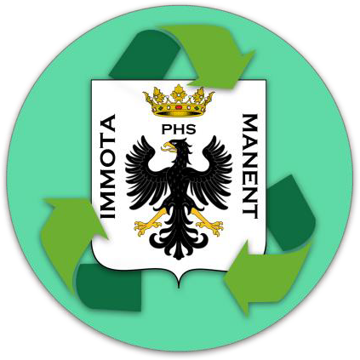

DifferenziAquila

**Design documentation**

**This is an example document from last years, so it does not mean as it is a perfect example to follow**

**(be creative)**

|  |  |  |
| --- | --- | --- |
| **Name** | **Student Number** | **E-mail address** |
|  |  |  |

# Strategy

## Product Overview

DifferenziAquila is an app that helps citizens in the activity of selective waste collection in the municipality of L’Aquila, providing tools and information that allow to communicate directly with the recycling company making the main services (such as requesting a special waste disposal) available directly from your smartphone.

The app aims to be usable by a vast diversified audience, from “middle-aged moms” to offsite students.

## Competitors

* [Juker](https://play.google.com/store/apps/details?id=it.giunko.junker&hl=it): “The first interactive app for the proper disposal of household waste”, its main goal is to tell the user how to properly separate waste and to provide basic information about the local recycling company (schedule, collection points location etc...). Junker’s main issue is that it doesn’t allow a direct user-company interaction and it is not currently available for the municipality of L’Aquila (just an example).
* Other similar apps are dedicated to specific municipalities, so they are not considered as direct competitors.

in general, the other apps provide a lower level of interaction with the company and none of those tested has a notification system.

## User Research

The main need that DifferenziAquila aims to fill is the necessity to retrieve information about the schedule of waste collection and to interact with the recycling company without further losses of time.

* How many times have you forgotten to take out the right recycle bin?

From now on DifferenziAquila will notify you every evening telling you what is going to be collected the next morning (in some countries, each day is scheduled for a specific waste to be collected).

* How much time have you lost trying to find the right number to call the right office to request a special waste disposal?

Through DifferenziAquila you can forward a request directly with your smartphone and it will also inform you about disservices or schedule variations.

DifferenziAquila wants to achieve that by providing an easy-to-use environment that allow the user to access the services as fast as possible, as the DifferenziAquila user base is extremely wide (the average user age goes from 20 years and up), most of it is composed of people who do not necessarily have familiarity with technology.

The duration of the typical user session should be extremely short, the main reason is that the user does not want to invest time in these activities, because the selective waste disposal is already seen as a forced and annoying activity, DifferenziAquila aims to mitigate these feelings.

Probably all features will be used is situations where the user is in a hurry, or he’s doing something else at the same time, so every functionality must be reached in as few taps as possible and all the interactions must be quick and focused to the result.

## Personas

### Gabriella



|  |  |
| --- | --- |
| **Age:** 55 | **Occupation:** Biologist |
| **Family:** Married, 2 children, 2 dogs | **Internet use:** Facebook, Internet Banking and simple searches |
| **Technical profile:** Totally uncomfortable with technology, Samsung A3 |  |

Gabriella is a mom of two children with a full-time job and two dogs, she is the one that takes care of the house. She is so busy that she often forgets to take out the trash bin, so the waste starts to accumulate in the back of the house.

### Luca



|  |  |
| --- | --- |
| **Age:** 21 | **Occupation:** Offsite student |
| **Family:** Engaged for 2 years | **Internet use:** Social networks, university research |
| **Technical profile:** Very comfortable with technology, Apple iPhone 7 | |

Luca is an undergraduate at UNIVAQ. He shares his apartment with other 3 colleagues. He doesn’t know how separate waste collection works in L’Aquila and he is too busy to go and ask for information about it. Also, being without a car, he has difficulties reaching the company offices to get the physical calendar and the recycling sacks.

### Mauro



|  |  |
| --- | --- |
| **Age:** 40 | **Occupation:** Electrical engineer |
| **Family:** Single | **Internet use:** Facebook, scientific researches |
| **Technical profile:** Somewhat comfortable with technology, Huawei p9 | |

Mauro is an electrical engineer, he is an “old school” man that prefers paper and pencil to a pc even if he’s starting to embrace the new technologies. He lives alone and he has some difficulties managing all the housework. He often uses his house as a laboratory, so he sometimes need to dispose special wastes.

# Scope

## Features

Main features:

* **Notify** the user about what is going to be collected the next morning

The user can choose the desired time at which the notification will be sent (if he wants).

* Show the user the selective **waste collection schedule** through a digital calendar
* **Book** a special waste collection and disposal

The user can choose from a list of dates and times when a company employee can come and pick up the special wastes.

* **Order** recycling sacks

The user can order a certain quantity of recycling sacks (directly provided by the company) to be delivered to his address.

* Get **communications** from the company

The user will be notified whenever there are disservices or changes to the calendar.

* Show the user a **map** of waste collection points

Rules and constraints:

* **Few views** and easily navigable
* Everything must be done in at most **3 taps**
* Everything must be done **inside** the app (no external links, external maps etc…)
* **Ask for user’s credentials only when necessary** (checking the calendar, receiving notifications and consulting the map, for example, do not require authentication)
* **Avoid the use of the keyboard** (when possible)

## Scenarios

### C:\Users\vale9\AppData\Local\Microsoft\Windows\INetCache\Content.Word\417382_293754414023970_1272081058_n.jpgScenario 1:

Gabriella has just finished washing the dishes and, after a long day of hard work she goes sleep. Between fatigue and various thoughts, she forgets to take out the trash bin.

The next morning, when she wakes up, she takes out the trash and she realizes that, since it is not the first time, the garbage began to accumulate

in the back of the house.

At work, the colleagues (who had the same problem) talk to her about DifferenziAquila and how they managed to solve this issue with it.

Gabriella choose to receive a notification every evening at 10pm so she quickly knows what is going to be collected the next day and she never misses a collection.

### C:\Users\vale9\AppData\Local\Microsoft\Windows\INetCache\Content.Word\adult-student-e12920888074681.jpgScenario 2:

Luca and his friends are cleaning the kitchen after the lunch, they realize that they are running out of recycling sacks and every time they have to take out the garbage they have to visit the company website to check the schedule.

Being without a car, they have difficulties reaching the company offices to get the physical calendar and the recycling sacks.

Luca is very confident with technology and he decides to check the store to see if there is something that can help him and his friends.

After installing DifferenziAquila and providing his client code, he quickly sends a recycling sacks request, and he goes back to what he was doing.

### C:\Users\vale9\AppData\Local\Microsoft\Windows\INetCache\Content.Word\MSambi2015.jpgScenario 3:

Mauro has a very old bunch of batteries to dispose in his “home lab”.

He isn’t very confident with technology, but he finally convinced himself that it is time to find information about the local special waste disposal procedure.

He hasn’t time to consult the company’s webpage so, using his smartphone, he decides to check the app store.

After a couple of minutes, he finds DifferenziAquila, through its easy-to-use interface he quickly finds the special waste collection request, logging in with his client code he doesn’t even need to provide his address.

In a few taps he choose a time that does not conflict with his working hours and send the request.

# Structure

## Navigation model

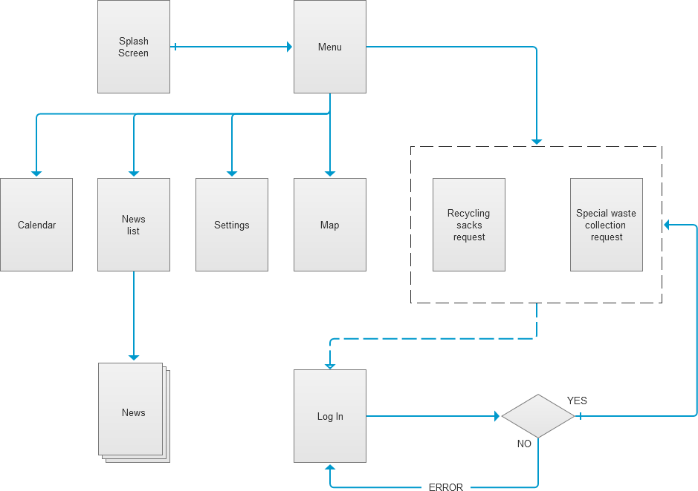

### Splash Screen:

This is the opening view of DifferenziAquila. The user will see this view when he starts the app.

### Menu:

This view is the first interactive view of DiferenziAquila: here the user can choose what to do and what to see.

We decided to create this view because we want to give the user the possibility to immediately choose what to do right after opening the app.

### Calendar:

This view exhibits the selective waste collection schedule through a digital calendar.

### News list:

This view contains the list of news and essentials communications. Disservices and calendar changes will be published on this page.

### News:

This is the view that shows the details of a single news.

### Settings:

This is where the user can choose (if and) when to receive notifications and find information about the company.

### Map:

This view shows all special wastes collection points, such as used oils, used batteries, clothes, etc.

### Log In:

This is the view that allows the user to log in and consequently allow the user to access the customer reserved areas.

We decided to restrict the access only when necessary, so the user can still use the other features without annoying delays.

### Recycling sacks request:

This is the first reserved view where the user can access only after logging in.

This view allows the user to order a certain amount of recycling sacks. Indeed, we have assumed that the company provides adequate waste bags for each type.

### Special waste collection request:

This is the second reserved view where the user can access only after logging in. This view consists of a request form that is used to book a special waste collection.

In this form, the user has to provide some basic information about the items and can choose when he prefers to receive the staff.

## Data

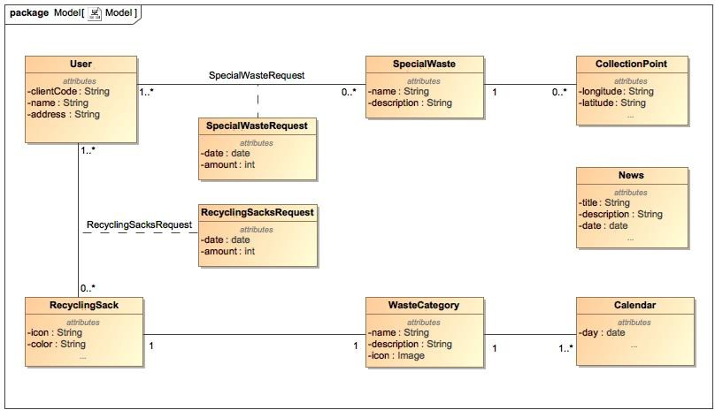

### User:

The User entity represents the users with their basic information.

### SpecialWaste:

The SpecialWaste entity contains the description of a certain special waste (used oils, old clothes, old TVs…). Some special wastes can or can’t have a relative **collection point** (for example: old clothes and used oils have specific collection points, but TVs or refrigerators have not).

### SpecialWasteRequest:

The SpecialWasteRequest (Special Waste Collection Request) entity contains the data about the request for a special waste collection.

A special waste collection request can be submitted if there are not collection points available for that specific special waste, therefore company’s employee’s action is required.

### RecyclingSack:

The RecyclingSack entity contains the description (icon to be presented in the app, color) of a certain recycling sack.

Every recycling sack refers to a certain waste category (plastic, organic, etc.).

Every user can order zero or more sacks, every (type of) sack can be ordered by 1 or more users.

### RecyclingSacksRequest:

The RecyclingSacksRequest entity contains the data about the user’s recycling sacks request.

### Calendar:

The Calendar entity contains the data about the collection schedule. Every day a certain waste category will be collected.

### WasteCategory:

The WasteCategory entity contains the data about the waste categories (plastic, paper, oganic, etc.) with their name, description and icon.

### News:

The News entity contains the details of a single news, the news are single announcements issued by the collection company and they are not related to a specific day/waste category.

### CollectionPoints:

The CollectionPoints entity represents the geographical location of all the collection points for small special wastes (such as used oils, used batteries, clothes, etc.).

# Skeleton

Full-resolution image at /diagrams/navigationWithViews.png.

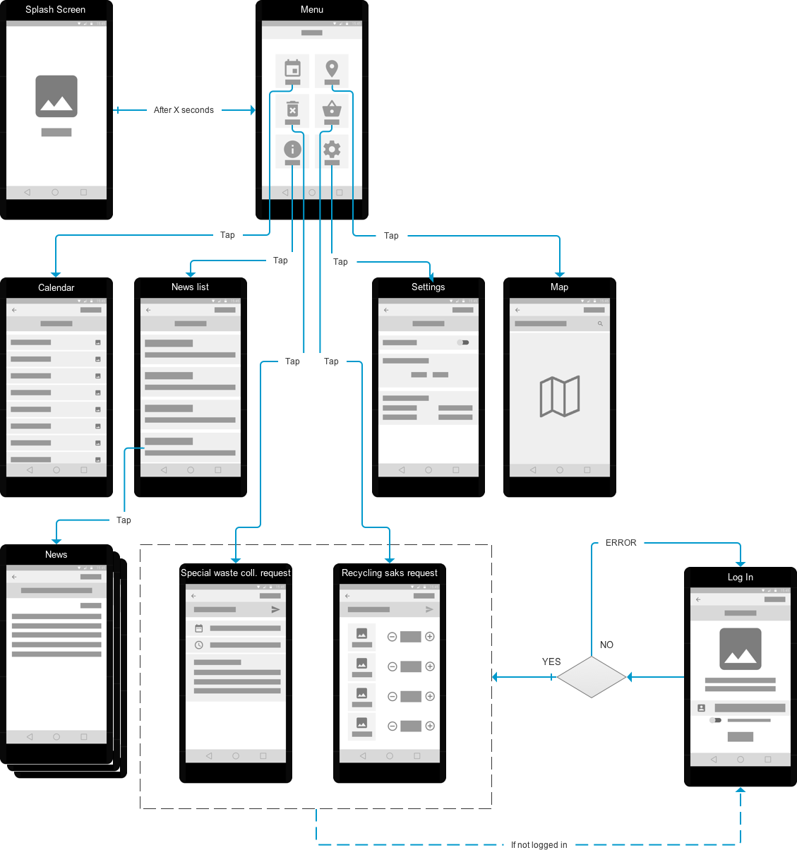

### C:\Users\valen\AppData\Local\Microsoft\Windows\INetCache\Content.Word\Splash Screen.pngSplash Screen:

In the Splash Screen we chose to show the app’s logo and the app’s name, it will last for a couple of seconds before redirecting the user to the Menu view.

Once the user reaches the Menu he can’t go back to the Splash Screen.

### C:\Users\valen\AppData\Local\Microsoft\Windows\INetCache\Content.Word\Menu.pngMenu:

This view is the central hub of the app. Here the user can choose what to do simply by tapping on one icon.

We chose this kind of menu because we want all the features immediately available, in the upper portion of the screen there is the application’s name.

Every feature is represented by a big icon and a short description, we decided to implement the **symmetry** design principle arranging the elements in the same way on both sides of an axis, providing the user an easy to read interface.

### C:\Users\valen\AppData\Local\Microsoft\Windows\INetCache\Content.Word\Calendar.pngCalendar:

The Calendar view is reached by tapping on the calendar icon on the menu view.

In the upper portion of the screen there is the application’s name, and a back button that allows the user to go back to the menu view (this is repeated on all views).

Under the app’s name there is a label specifying the month-year that the user is currently browsing.

For this view, we used the **axis** design principle, on the left side there are the days, and on the right, there are icons that indicate the type of waste that will be collected that day.

The user can also scroll the calendar to check the following days (**infinite axis** design principle).

### C:\Users\valen\AppData\Local\Microsoft\Windows\INetCache\Content.Word\News List.pngNews List:

The News List view is reached by tapping on the news list icon on the menu view.

This is very important for the user as it will be used to informed in real time through a notification.

Under the app’s name there is a label specifying the view that the user is currently browsing.

Every news is represented by its title and the first line of its content and it is grouped in a “box”.

We chose to use the **infinite axis** design principle to allow the user to scroll through the older news.

### C:\Users\valen\AppData\Local\Microsoft\Windows\INetCache\Content.Word\News.pngNews:

The News view is reached by tapping on a news on the news list view. Under the app’s name there is a label specifying the title of the news. Next there is the date of publication and the body of the news.

### C:\Users\valen\AppData\Local\Microsoft\Windows\INetCache\Content.Word\Settings.pngSettings:

The Settings view is reached by tapping on the settings icon on the menu view.

Under the app’s name there is a label specifying the view that the user is currently browsing.

It is a very friendly and simple view: the user can choose if he wants to receive notifications or not through a check box and if he wants to, he can choose when to receive them.

On the bottom there is a box containing some basic information about the application and the recycling company.

### C:\Users\valen\AppData\Local\Microsoft\Windows\INetCache\Content.Word\Map.pngMap:

The Map view is reached by tapping on the map icon on the menu view. Under the app’s name there is a search bar where the user can input a specific address to check if there are collection points nearby.

In this view, the user, through a simple search can find the collection points closer to his house or near his location.

To represent the map we chose to implement the **infinite area** design principle, so the user can scroll across the whole map even if there is only a small portion displayed on the screen.

### C:\Users\valen\AppData\Local\Microsoft\Windows\INetCache\Content.Word\Recycling Sacks Request.pngRecycling Sacks Request:

The Recycling Sacks Request view is reached by tapping on the recycling sacks request icon on the menu view.

Under the app’s name there is a label specifying the view that the user is currently browsing and there is the “send” button that allow the user to send the request (this is also used in the Special Waste Collection Request view).

With this view the user can order the recycling sacks and have them

brought to his house the next working day.

The body of the view consist in four repeated sections, we chose the **axis** and **rhythm** design principle to achieve a simple and familiar user interface. The user can add and remove each kind of sack by tapping on the “+” and “-“ icons, avoiding the use of the keyboard.

### C:\Users\valen\AppData\Local\Microsoft\Windows\INetCache\Content.Word\Special Waste Collection Request.pngSpecial Waste Collection Request:

The Special Waste Collection Request view is reached by tapping on the special waste collection request icon on the menu view.

With this view the user can book a special waste collection, the special wastes will be taken directly from his address at the desired date.

The user has to choose a date and a time slot, he also has to provide a short description of the items to be disposed.

On submitting the request (this is also valid for the Recycling Sacks Request view) a success/failure message will be displayed on the upper portion of the screen.

### C:\Users\valen\AppData\Local\Microsoft\Windows\INetCache\Content.Word\LogIn.pngLog In:

This view is only reachable when the user tries to access on the restricted access views and only if the user is not already logged in.

There is a label with the name of the view, in the view’s body there is the app’s logo and a short set of instructions to log in.

In the lower portion of the screen there is the text field where the user will insert is client code, a checkbox that asks the user if he wants to be “remembered” and a big centered log in button.

We chose to keep this view as simple as possible but still providing essential information and features (“remember me”, instructions on how to retrieve a lost code etc.).

On tapping the log in button a success/failure message will be displayed on the upper portion of the screen.

If the log in is successful the user will be redirected on the view he was trying to access, on failure the user will be redirected back on the log in view.

The back button (top-left corner) will bring the user back to the menu view.

### Notes:

* Tapping wireframes/pics/back.png on every view will bring the user back to the Menu view.
* If the authentication process fails, the user will be redirected back to the Log in view with an error message displayed at the top of the screen.
* The Log in view will be presented only when the user tries to access the Special waste collection request or the Recycling sacks request views, the other views do not require the user the be authenticated.
* If the user decides to be "remembered" the Log in view will be presented only at the first access.
* The Splash screen view is the first view to be presented to the user, it will be visible for a short amount of time and then the user will be redirected to the Menu view.
* The Special waste collection request or the Recycling saks request views will inform the user about the request success/failure with a message displayed at the top of the screen.

# Surface

The **color** green relates to balance and harmony, growth and environment.

DifferenziAquila is an app dedicated to recycling and the environment, so the choice of colors has been fairly obvious.

We chose to use a **monochromatic** combination of colors to communicate a sense of uniformity and order, we avoided to use bright colors that could have been annoying for the user.

Helped by [Adobe Color](https://color.adobe.com/create/color-wheel) we chose the following set of greens:

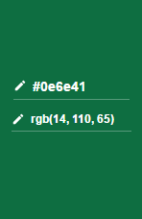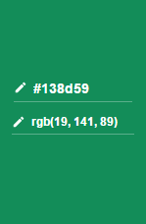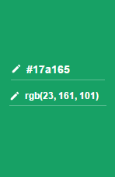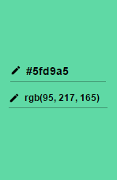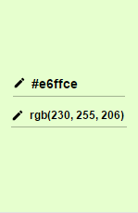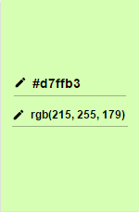

The chosen **font** is **Lato**, it is a sans serif typeface family, the semi-rounded details of the let- ters give Lato a feeling of warmth, while the strong structure provides **stability, seriousness,** and it is **very easy to read.**

Furthermore, Lato is one of the most used font on mobile and web applications.

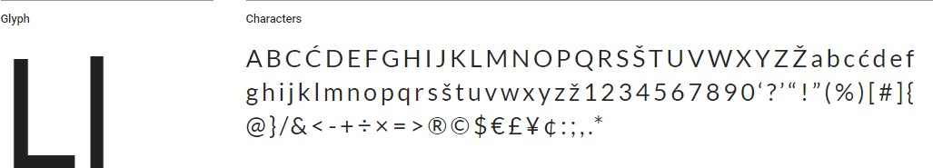

The **icon** has been created combining the classic symbol of separate waste collection and an eagle.

The background is rounded and uses one of the colors used inside the app, all the objects on the foreground have a thin shadow that helps to add dimensionality and depth (as suggested by google’s material design guidelines).

**HiFi wireframes** (Main Menu and Calendar, generated by coloring the respective LoFi):

